Foundation species genotypic variation should structure ecological interaction networks by altering co-occurrence frequencies

M.K. Lau, S.M. Shuster, K. Whitley, S. Borrett, T.G. Whitham

Abstract.

* Ecosystem function and dynamics are intrinsically linked to communities of organisms that interact in complex networks
* Previous work has shown that both that community patterns have a genetic basis; however the related theory has not explored the potential for a genetic basis to complex interaction networks
* In this study, we use simple, mass-action based simulations previously developed in Shuster et al. 2006 and network modeling to explore the possible effect that genetic variability in foundation species can influence the structure of ecological networks
* Four main findings emerged:
  1. Environmental variation did not influence network size (measured by the number of significant co-occurrence patterns), but did contribute to spurious genetic patterns (i.e. observing a large genetic effect when selection intensity was low)
  2. Network size exhibited an exponential increasing response to the intensity of selection
  3. All networks with significant structure had multivariate R2 values greater than 0.5
  4. (NOTE: I still need to look into this one) Using co-occurrence probabilities to adjust the predicted frequency of interactions among species of in hypothesized networks, we found that interaction network structure was strongly impacted by underlying genetic variability on the foundation species
* The results confirm that genetic variability in a foundation species can have significant effects on interaction network structure through its influence on species co-occurrence patterns. We can thus expect that even complex ecological networks should show significant effects of foundation species genetic variability even in communities of diffusely interacting species.

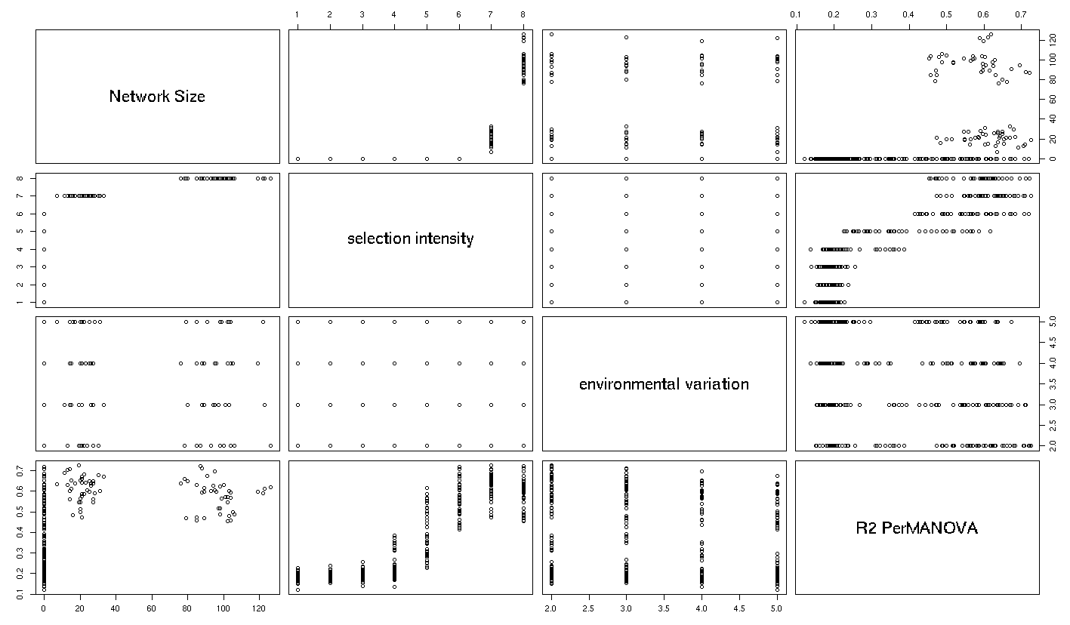

**Figure 1**. Matrix of bivariate plots showing the relationships between Network Size, Selection Intensity, Environmental Variation and multivariate R2 from the simulations of the effect of genetic variation in a foundation species on dependent species.